**Aerodynamic Performance Engineer - Recruitment Exercise (October 2023)**

You are being asked to consider a problem that is representative of the day-to-day challenges likely to be experienced while working within our group. The task is chosen so that we can engage with you as a professional engineer to learn more about your **problem solving** and **presentation skills**. The outcome of the exercise in itself is unimportant. You are free to choose your own approach and software (excel, python, matlab, powerpoint, etc…) to dig into the problem and present some observations.

Should you have any question, please feel free to contact us. If opening the files and dealing with the dataset is problematic, let us know. A set of key plots can be provided to support the analysis.

Ideally a total of 2-3 hours should be sufficient to gain an understanding of the dataset. You will be asked to present your findings in ~15-20mins.

**Exercise**

Alpine F1 tested a new front wing at the last event. The aim was to get a better flowfield management.

* Lap 1 to 3 were done with front wing A (baseline)
* Lap 4 to 6 were done with front wing B (update)
* The car was rebalanced between the 2 runs
* The driver commented on “weaker performance with front wing B in the very low speed turn 5 but stronger in the last sector”

The track dataset is attached (.csv format) with the following parameters included:

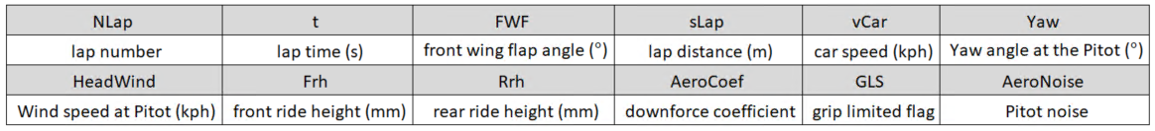

The latest wind tunnel delta delivered by the Aero department is the following

|  |  |  |  |  |  |  |  |  |  |  |  |
| --- | --- | --- | --- | --- | --- | --- | --- | --- | --- | --- | --- |
| Front wing | FWF | Frh | Rrh | Yaw | AeroCoef | Front wing | FWF | Frh | Rrh | Yaw | AeroCoef |
| A | 16 | 20 | 120 | 0 | -2.102 | B | 16 | 20 | 120 | 0 | -2.1132 |
| A | 16 | 20 | 120 | -2 | -2.0588 | B | 16 | 20 | 120 | -2 | -2.1278 |
| A | 16 | 20 | 120 | -4 | -1.8891 | B | 16 | 20 | 120 | -4 | -2.0121 |
| A | 16 | 20 | 120 | -6 | -1.8236 | B | 16 | 20 | 120 | -6 | -1.9558 |
| A | 16 | 20 | 120 | 2 | -1.9561 | B | 16 | 20 | 120 | 2 | -2.0131 |
| A | 16 | 20 | 120 | 4 | -1.9298 | B | 16 | 20 | 120 | 4 | -2.0528 |
| A | 16 | 20 | 120 | 6 | -1.7512 | B | 16 | 20 | 120 | 6 | -1.886 |
| A | 16 | 10 | 80 | 0 | -2.0858 | B | 16 | 10 | 80 | 0 | -2.0968 |
| A | 16 | -5 | 40 | 0 | -1.9564 | B | 16 | -5 | 40 | 0 | -1.9694 |

And the CFD data is

|  |  |  |  |  |  |  |  |  |  |  |  |
| --- | --- | --- | --- | --- | --- | --- | --- | --- | --- | --- | --- |
| Front wing | FWF | Frh | Rrh | Yaw | AeroCoef | Front wing | FWF | Frh | Rrh | Yaw | AeroCoef |
| A | 16 | 20 | 120 | 0 | -2.2924 | B | 16 | 20 | 120 | 0 | -2.3269 |

You have been tasked to report on the track test

* What can you comment from the test ? (procedure, data quality, instrumentation, …)
* Did the front wing perform as expected by the tools ?
* Would it be beneficial to continue running the FW in this event?